
Assignment # 01
Student Name: | Farhat Naz
Registration ID: | 844005
Course Code: | 8611
Course Title:

Q.1: Why in human civilization do critical thinkers challenge the status quo?
Critical thinking is a vital skill in human civilization that allows individuals to analyze, evaluate, and subsequently challenge existing beliefs and norms. This questioning of the status quo is essential for progress as it fosters innovation, social justice, and deeper understanding. By engaging with and questioning established ideas, critical thinkers play a crucial role in shaping society's evolution.
1. Definition of Critical Thinking
Critical thinking involves the ability to think clearly and rationally, understanding the logical connection between ideas. It includes analyzing facts, interpreting data, and reasoning in a manner that leads to sound conclusions. This skill is not inherently about finding fault in ideas but rather assessing their validity.
2. Historical Context of Challenging the Status Quo
Throughout history, individuals who challenge the status quo have often been catalysts for societal change. From the Enlightenment philosophers who questioned traditional authorities to civil rights activists who fought against systemic injustice, these figures illustrate the impact of critical thinking on civilization.
3. The Role of Critical Thinkers in Society
Critical thinkers often assume roles as educators, scientists, and activists. Their ability to question and analyze societal constructs allows them to identify flaws in existing systems and propose alternatives. This can lead to reforms in education, governance, and social practices.
4. Psychological Underpinnings of Challenging Norms
Psychologically, critical thinkers may possess traits such as open-mindedness, skepticism, and a willingness to consider multiple perspectives. These traits enable them to resist conformity and engage in robust debates over accepted practices.
5. Communication and Advocacy
Effectively challenging the status quo requires not just critical thinking but also communication skills. Critical thinkers must articulate their views convincingly to persuade others of the need for change. Advocacy for new ideas often becomes a crucial component of their efforts.
6. The Impact of Technology on Critical Thinking
In the modern age, technology plays a significant role in the dissemination of ideas. The internet and social media allow critical thinkers to share their insights widely and engage in dialogues that can challenge traditional norms on a global scale.
7. Overcoming Resistance to Change
Generating change is fraught with challenges. Societal inertia, fear of the unknown, and vested interests often counteract the efforts of critical thinkers. Overcoming this resistance requires persistence and strategic approaches to reform.
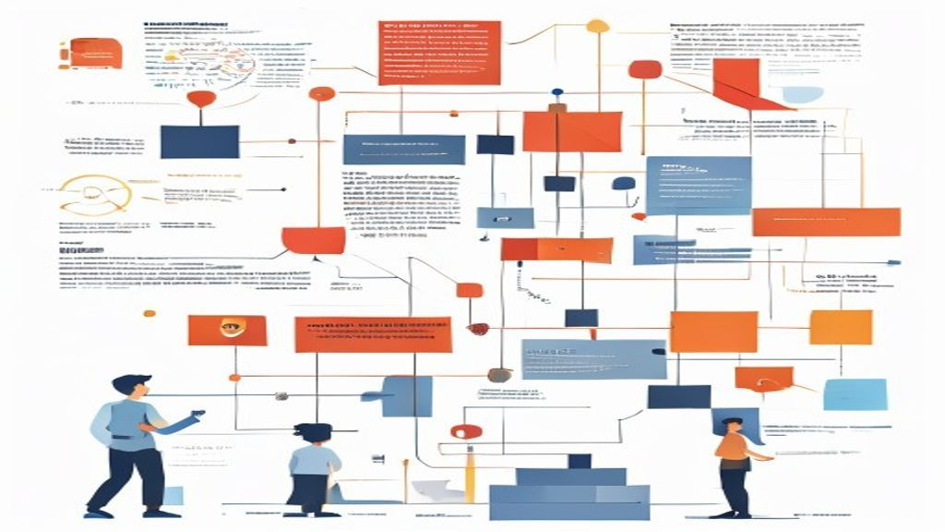
Conclusion
In conclusion, critical thinkers challenge the status quo through their capacity to engage in thoughtful analysis and articulate alternative perspectives. This challenge is essential for societal growth, driving innovation and reform in various sectors. By questioning established norms, critical thinkers not only promote their own understanding but also foster a more progressive and open-minded society.

